Proiect   
  
Scop

Crearea unei aplicatii pentru gestionarea biletelor si a filmelor pt un cinema.

1. Creare colectii

create.js:

use('proiect');

db.customers.drop();

db.prices.drop();

db.tickets.drop();

db.movies.drop();

db.createCollection("customers");

db.createCollection("prices");

db.createCollection("tickets");

db.createCollection("movies");

2. Inserare Date

insert.js:

use('proiect');

db.customers.insertMany([

{

_id: 'c1',

first_name: 'john',

last_name: 'smith',

phone: '0711111111',

email: 'john.smith@gmail.com'

},

{

_id: 'c2',

first_name: 'anna',

last_name: 'brown',

phone: '0722222222',

email: 'anna.brown@gmail.com'

},

{

_id: 'c3',

first_name: 'mike',

last_name: 'johnson',

phone: '0733333333',

email: 'mike.johnson@gmail.com'

},

{

_id: 'c4',

first_name: 'lisa',

last_name: 'wilson',

phone: '0744444444',

email: 'lisa.wilson@gmail.com'

},

{

_id: 'c5',

first_name: 'alex',

last_name: 'taylor',

phone: '0755555555',

email: 'alex.taylor@gmail.com'

},

{

_id: 'c6',

first_name: 'emma',

last_name: 'anderson',

phone: '0766666666',

email: 'emma.anderson@gmail.com'

},

{

_id: 'c7',

first_name: 'daniel',

last_name: 'thomas',

phone: '0777777777',

email: 'daniel.thomas@gmail.com'

},

{

_id: 'c8',

first_name: 'sophia',

last_name: 'martin',

phone: '0788888888',

email: 'sophia.martin@gmail.com'

},

{

_id: 'c9',

first_name: 'chris',

last_name: 'lee',

phone: '0799999999',

email: 'chris.lee@gmail.com'

},

{

_id: 'c10',

first_name: 'olivia',

last_name: 'clark',

phone: '0700000000',

email: 'olivia.clark@gmail.com'

},

{

_id: 'c11',

first_name: 'andrew',

last_name: 'lewis',

phone: '0712345678',

email: 'andrew.lewis@gmail.com'

},

{

_id: 'c12',

first_name: 'mia',

last_name: 'walker',

phone: '0723456789',

email: 'mia.walker@gmail.com'

},

{

_id: 'c13',

first_name: 'james',

last_name: 'hall',

phone: '0734567890',

email: 'james.hall@gmail.com'

},

{

_id: 'c14',

first_name: 'isabella',

last_name: 'young',

phone: '0745678901',

email: 'isabella.young@gmail.com'

},

{

_id: 'c15',

first_name: 'robert',

last_name: 'king',

phone: '0756789012',

email: 'robert.king@gmail.com'

},

{

_id: 'c16',

first_name: 'amelia',

last_name: 'wright',

phone: '0767890123',

email: 'amelia.wright@gmail.com'

},

{

_id: 'c17',

first_name: 'david',

last_name: 'lopez',

phone: '0778901234',

email: 'david.lopez@gmail.com'

},

{

_id: 'c18',

first_name: 'charlotte',

last_name: 'hill',

phone: '0789012345',

email: 'charlotte.hill@gmail.com'

},

{

_id: 'c19',

first_name: 'kevin',

last_name: 'scott',

phone: '0790123456',

email: 'kevin.scott@gmail.com'

},

{

_id: 'c20',

first_name: 'eva',

last_name: 'green',

phone: '0701234567',

email: 'eva.green@gmail.com'

}

]);

db.movies.insertMany([

{

name: 'Anaconda',

length_minutes: 100,

minimum_age: 12,

genre: ['Action', 'Adventure', 'Comedy', 'Thriller', 'Horror'],

date: new Date("2026-01-30")

},

{

name: 'Avatar:Fire and Ash',

length_minutes: 197,

minimum_age: 12,

genre: ['Action', 'Adventure', 'Fantasy', 'Thriller'],

date: new Date("2025-12-19")

},

{

name: 'Bloody Chrismas',

length_minutes: 97,

minimum_age: 18,

genre: ['Horror'],

date: new Date('2025-12-12')

},

{

name: 'Cravata Galbena',

length_minutes: 145,

minimum_age: 0,

genre: ['Drama', 'Adventure', 'Musical'],

date: new Date('2025-11-14')

},

{

name: 'Colors of Time',

length_minutes: 124,

minimum_age: 12,

genre: ['Drama', 'Crime', 'Thriller', 'Comedy'],

date: new Date('2025-12-19')

},

{

name: 'Five nights at Freddy`s 2',

length_minutes: 104,

minimum_age: 15,

genre: ['Horror', 'Mistery', 'Thriller'],

date: new Date('2025-12-05')

},

{

name: 'The Housemaid',

length_minutes: 132,

minimum_age: 15,

genre: ['Thriller'],

date: new Date('2026-01-02')

},

{

name: 'I didn`t have a choice',

length_minutes: 139,

minimum_age: 15,

genre: ['Horror', 'Comedy', 'Crime', 'Thriller'],

date: new Date('2026-01-02')

},

{

name: 'Spongebob',

length_minutes: 96,

minimum_age: 0,

genre: ['Animation', 'Adventure', 'Familly', 'Comedy', 'Fantasy'],

date: new Date('2026-12-26')

},

{

name: 'Zootopia 2',

length_minutes: 107,

minimum_age: 0,

genre: ['Animation', 'Adventure', 'Familly'],

date: new Date('2025-11-28')

}

]);

db.prices.insertMany([

{

ticket_type: 'familly',

price: 30

},

{

ticket_type: 'student',

price: 25

},

{

ticket_type: 'senior',

price: 20

},

{

ticket_type: 'adult',

price: 45

},

{

ticket_type: 'child',

price: 20

}

]);

db.tickets.insertMany([

{

customer: 'c1',

movie: 'Anaconda',

ticket_type: 'adult',

date: new ISODate('2026-01-20T18:30:00Z'),

row: 5,

seat: 8,

room: 2,

cinema: { name: 'cinema1', city: 'Bucharest' }

},

{

customer: 'c2',

movie: 'Zootopia 2',

ticket_type: 'child',

date: new ISODate('2025-11-29T12:00:00Z'),

row: 3,

seat: 6,

room: 1,

cinema: { name: 'cinema2', city: 'Cluj' }

},

{

customer: 'c2',

movie: 'Spongebob',

ticket_type: 'familly',

date: new ISODate('2026-12-27T10:30:00Z'),

row: 4,

seat: 7,

room: 1,

cinema: { name: 'cinema2', city: 'Cluj' }

},

{

customer: 'c3',

movie: 'The Housemaid',

ticket_type: 'adult',

date: new ISODate('2026-01-05T20:00:00Z'),

row: 6,

seat: 11,

room: 3,

cinema: { name: 'cinema3', city: 'Timisoara' }

},

{

customer: 'c3',

movie: 'Colors of Time',

ticket_type: 'student',

date: new ISODate('2025-12-20T17:45:00Z'),

row: 2,

seat: 4,

room: 2,

cinema: { name: 'cinema3', city: 'Timisoara' }

},

{

customer: 'c4',

movie: 'Cravata Galbena',

ticket_type: 'senior',

date: new ISODate('2025-11-16T16:00:00Z'),

row: 1,

seat: 2,

room: 1,

cinema: { name: 'cinema1', city: 'Bucharest' }

},

{

customer: 'c4',

movie: 'Colors of Time',

ticket_type: 'adult',

date: new ISODate('2025-12-21T19:00:00Z'),

row: 7,

seat: 9,

room: 2,

cinema: { name: 'cinema1', city: 'Bucharest' }

},

{

customer: 'c5',

movie: 'Avatar:Fire and Ash',

ticket_type: 'adult',

date: new ISODate('2026-01-10T21:00:00Z'),

row: 8,

seat: 15,

room: 4,

cinema: { name: 'cinema4', city: 'Iasi' }

},

{

customer: 'c5',

movie: 'Anaconda',

ticket_type: 'adult',

date: new ISODate('2026-02-01T18:00:00Z'),

row: 6,

seat: 10,

room: 2,

cinema: { name: 'cinema4', city: 'Iasi' }

},

{

customer: 'c6',

movie: 'Spongebob',

ticket_type: 'familly',

date: new ISODate('2026-12-26T11:00:00Z'),

row: 2,

seat: 5,

room: 1,

cinema: { name: 'cinema2', city: 'Cluj' }

},

{

customer: 'c6',

movie: 'Zootopia 2',

ticket_type: 'familly',

date: new ISODate('2025-11-28T14:00:00Z'),

row: 3,

seat: 8,

room: 1,

cinema: { name: 'cinema2', city: 'Cluj' }

},

{

customer: 'c7',

movie: 'Five nights at Freddy`s 2',

ticket_type: 'student',

date: new ISODate('2025-12-06T22:00:00Z'),

row: 9,

seat: 18,

room: 5,

cinema: { name: 'cinema5', city: 'Brasov' }

},

{

customer: 'c7',

movie: 'I didn`t have a choice',

ticket_type: 'student',

date: new ISODate('2026-01-03T21:30:00Z'),

row: 8,

seat: 14,

room: 4,

cinema: { name: 'cinema5', city: 'Brasov' }

},

{

customer: 'c8',

movie: 'Spongebob',

ticket_type: 'child',

date: new ISODate('2026-12-26T11:00:00Z'),

row: 3,

seat: 4,

room: 1,

cinema: { name: 'cinema2', city: 'Cluj' }

},

{

customer: 'c9',

movie: 'Spongebob',

ticket_type: 'familly',

date: new ISODate('2026-12-26T11:00:00Z'),

row: 3,

seat: 5,

room: 1,

cinema: { name: 'cinema2', city: 'Cluj' }

},

{

customer: 'c10',

movie: 'Spongebob',

ticket_type: 'familly',

date: new ISODate('2026-12-26T11:00:00Z'),

row: 3,

seat: 6,

room: 1,

cinema: { name: 'cinema2', city: 'Cluj' }

},

{

customer: 'c11',

movie: 'Anaconda',

ticket_type: 'adult',

date: new ISODate('2026-01-20T18:30:00Z'),

row: 5,

seat: 9,

room: 2,

cinema: { name: 'cinema1', city: 'Bucharest' }

},

{

customer: 'c12',

movie: 'Anaconda',

ticket_type: 'student',

date: new ISODate('2026-01-20T18:30:00Z'),

row: 5,

seat: 10,

room: 2,

cinema: { name: 'cinema1', city: 'Bucharest' }

},

{

customer: 'c13',

movie: 'Avatar:Fire and Ash',

ticket_type: 'adult',

date: new ISODate('2026-01-10T21:00:00Z'),

row: 8,

seat: 16,

room: 4,

cinema: { name: 'cinema4', city: 'Iasi' }

},

{

customer: 'c14',

movie: 'Avatar:Fire and Ash',

ticket_type: 'student',

date: new ISODate('2026-01-10T21:00:00Z'),

row: 8,

seat: 17,

room: 4,

cinema: { name: 'cinema4', city: 'Iasi' }

},

{

customer: 'c15',

movie: 'Colors of Time',

ticket_type: 'adult',

date: new ISODate('2025-12-19T19:00:00Z'),

row: 7,

seat: 10,

room: 2,

cinema: { name: 'cinema1', city: 'Bucharest' }

},

{

customer: 'c16',

movie: 'Colors of Time',

ticket_type: 'senior',

date: new ISODate('2025-12-19T19:00:00Z'),

row: 7,

seat: 11,

room: 2,

cinema: { name: 'cinema1', city: 'Bucharest' }

},

{

customer: 'c17',

movie: 'Five nights at Freddy`s 2',

ticket_type: 'student',

date: new ISODate('2025-12-06T22:00:00Z'),

row: 9,

seat: 19,

room: 5,

cinema: { name: 'cinema5', city: 'Brasov' }

},

{

customer: 'c18',

movie: 'Five nights at Freddy`s 2',

ticket_type: 'adult',

date: new ISODate('2025-12-06T22:00:00Z'),

row: 9,

seat: 20,

room: 5,

cinema: { name: 'cinema5', city: 'Brasov' }

},

{

customer: 'c19',

movie: 'I didn`t have a choice',

ticket_type: 'adult',

date: new ISODate('2026-01-03T21:30:00Z'),

row: 8,

seat: 15,

room: 4,

cinema: { name: 'cinema5', city: 'Brasov' }

},

{

customer: 'c20',

movie: 'I didn`t have a choice',

ticket_type: 'child',

date: new ISODate('2026-01-03T21:30:00Z'),

row: 8,

seat: 16,

room: 4,

cinema: { name: 'cinema5', city: 'Brasov' }

}

]);

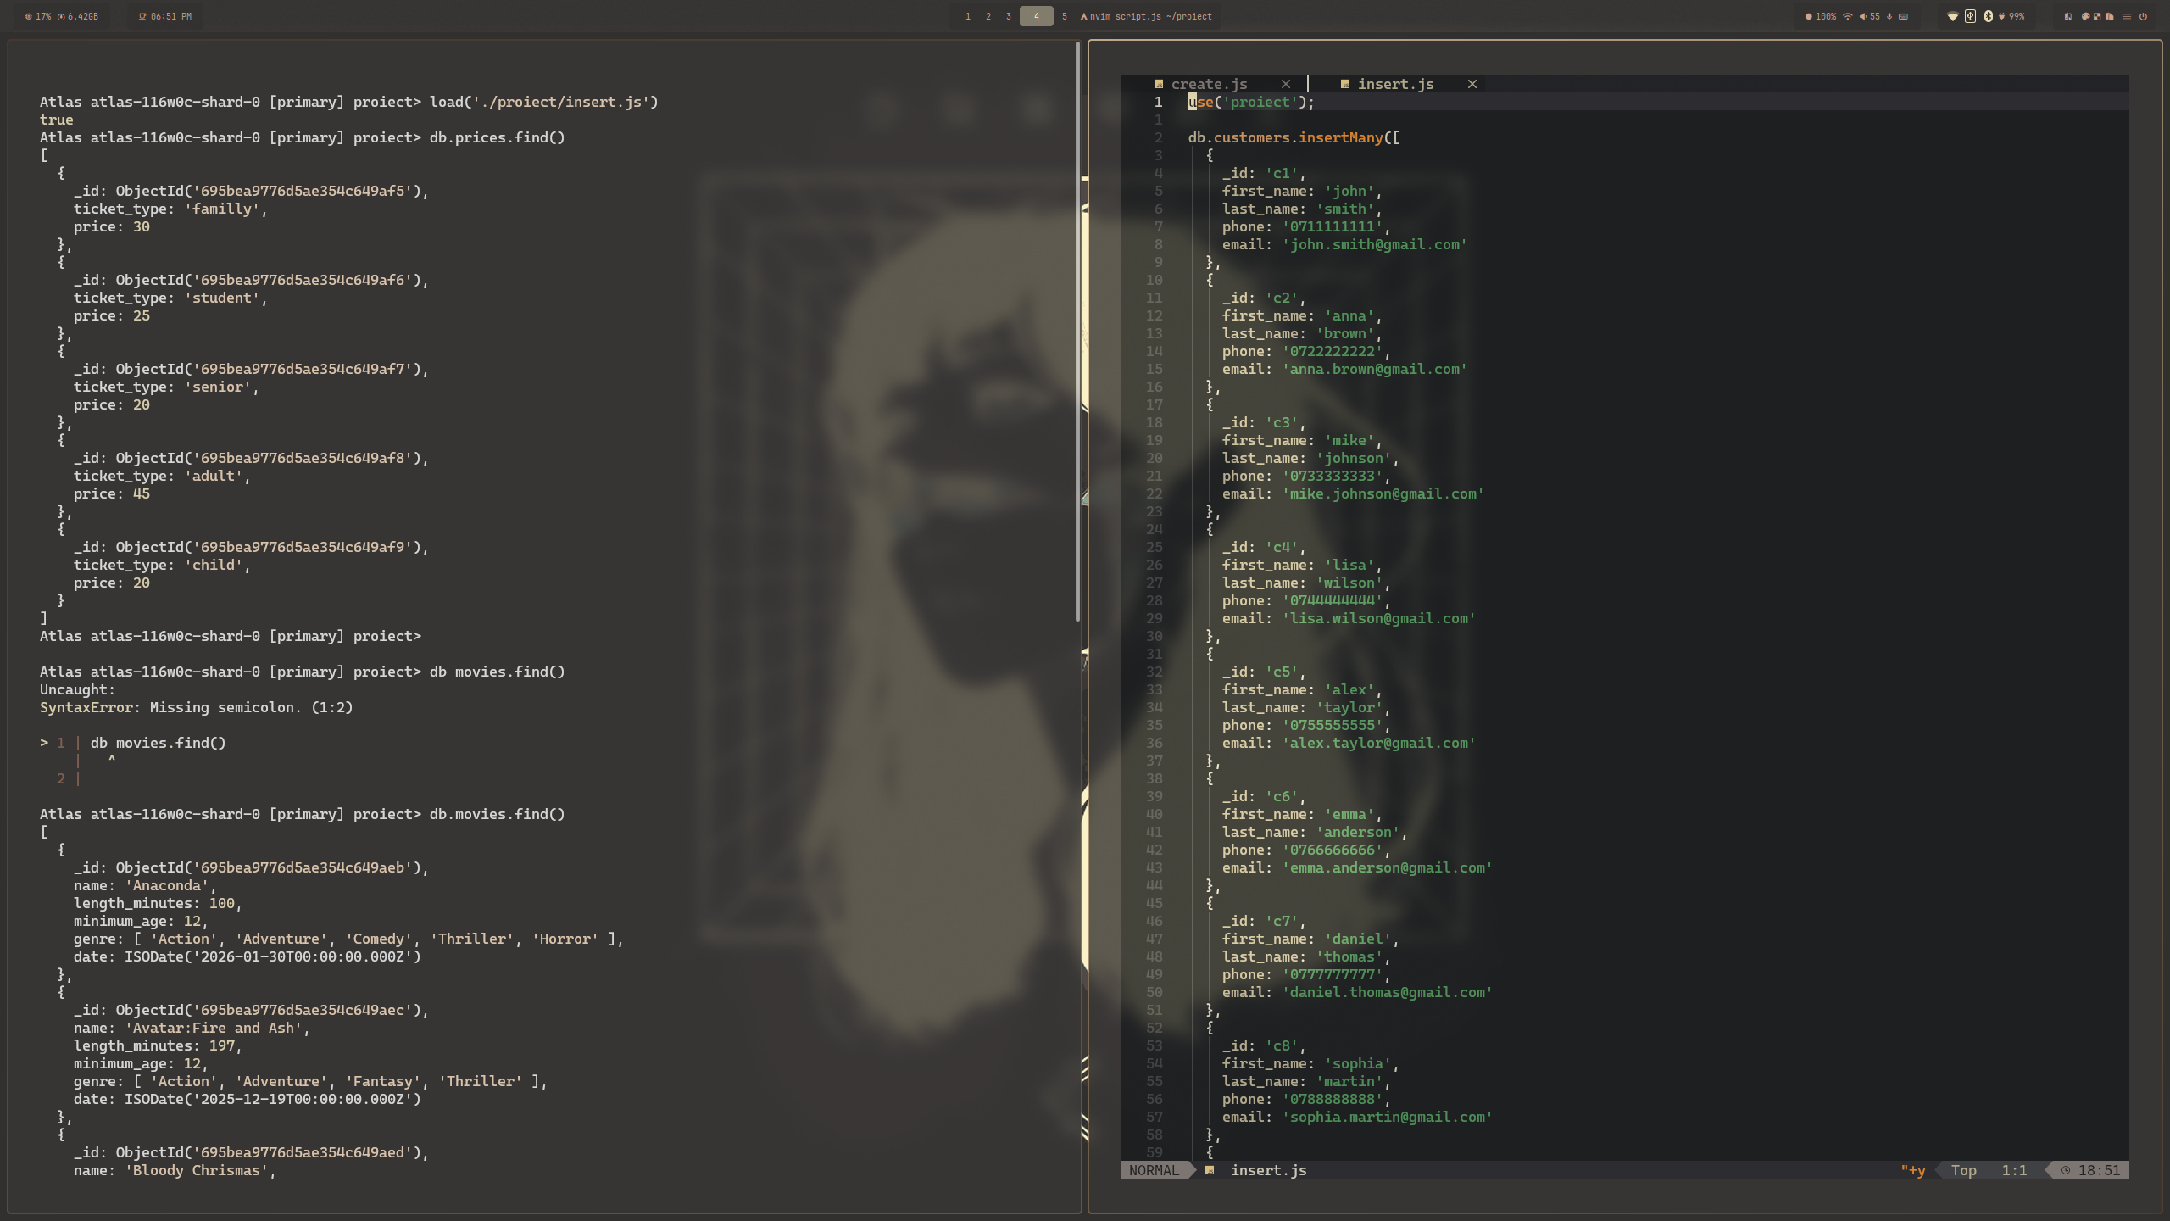  
3. Total generat de film + Nr bilete vandute

use('proiect');

printjson(

db.tickets.aggregate(

{

$lookup: {

from: "prices",

localField: "ticket_type",

foreignField: "ticket_type",

as: "price"

}

},

{

$unwind: '$price'

},

{

$group:

{

_id: '$movie',

total: { $sum: '$price.price' },

nOfTickets: { $sum: 1 }

}

},

{

$project:

{

_id: 0,

total: 1,

nOfTickets: 1,

movie: '$_id'

}

}

));

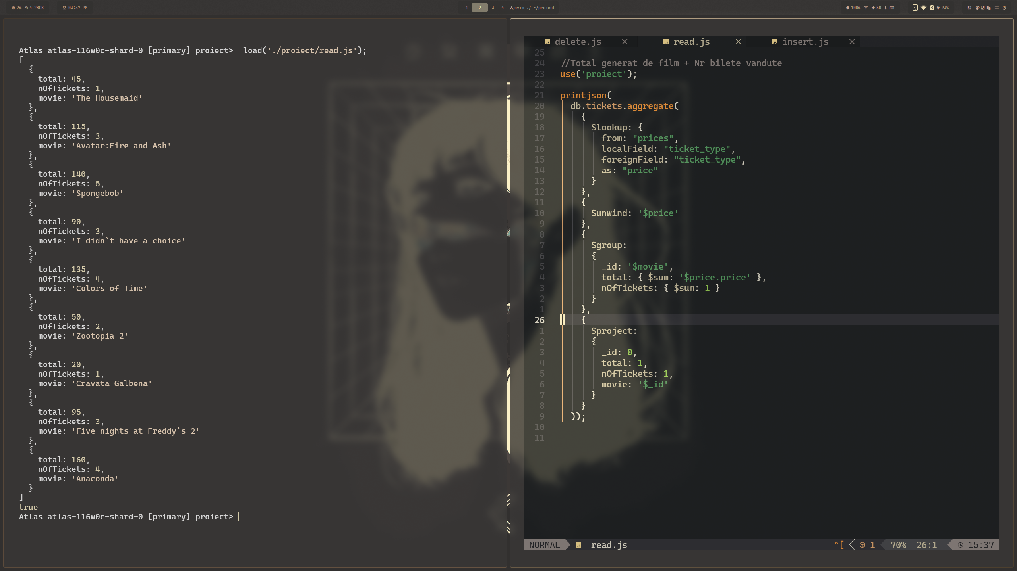

4. Movie Ranking

( sintaxa posibila doar pentru versiuni mai mari de 5.0, link: <https://www.mongodb.com/docs/manual/reference/operator/aggregation/setWindowFields/> )

printjson(

db.tickets.aggregate([

{

$group: {

_id: "$movie",

totalTickets: { $sum: 1 }

}

},

{ $sort: { totalTickets: -1 } },

{

$setWindowFields: {

sortBy: { totalTickets: -1 },

output: {

rank: { $rank: {} }

}

}

}

])

);

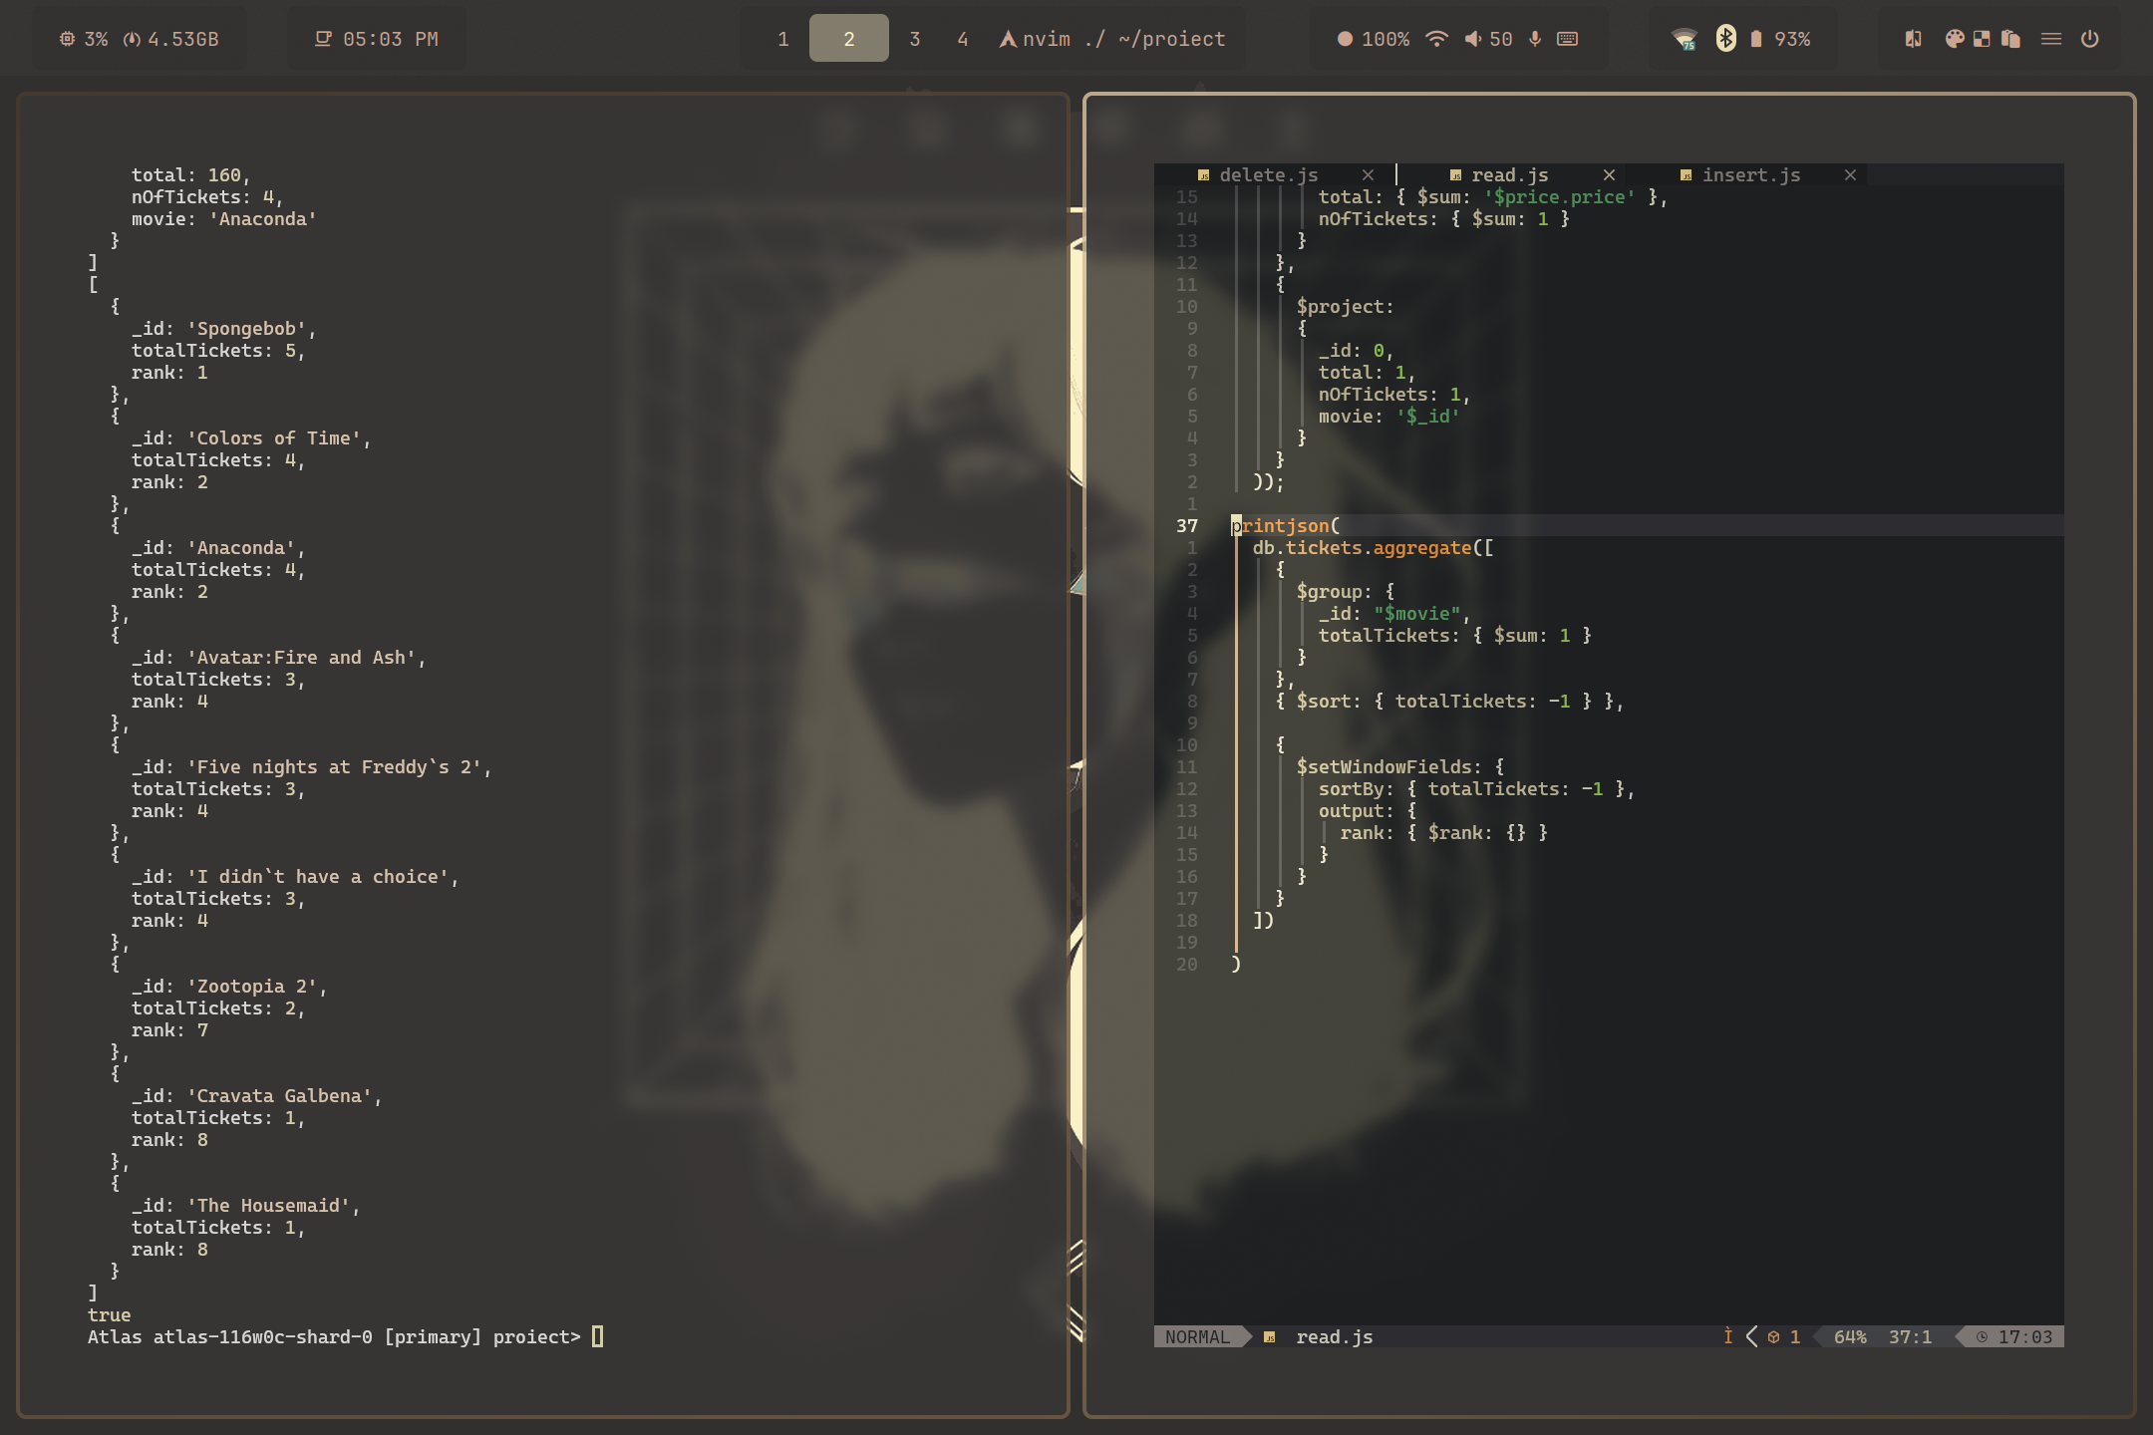  
5. Profit si numarul de bilete per categorie  
  
printjson(

db.tickets.aggregate(

{

$lookup: {

from: "prices",

localField: "ticket_type",

foreignField: "ticket_type",

as: "price"

}

},

{

$lookup: {

from: "movies",

localField: "movie",

foreignField: "name",

as: "movie"

}

},

{

$unwind: "$price"

},

{

$unwind: "$movie"

},

{

$unwind: "$movie.genre"

},

{

$group:

{

_id: "$movie.genre",

ticket_count: { $sum: 1 },

revenue: { $sum: '$price.price' }

}

},

{

$project:

{

_id: 0,

genre: '$_id',

ticket_count: 1,

revenue: 1

}

},

{

$sort: {

revenue: -1,

ticket_count: -1

}

}

)

);

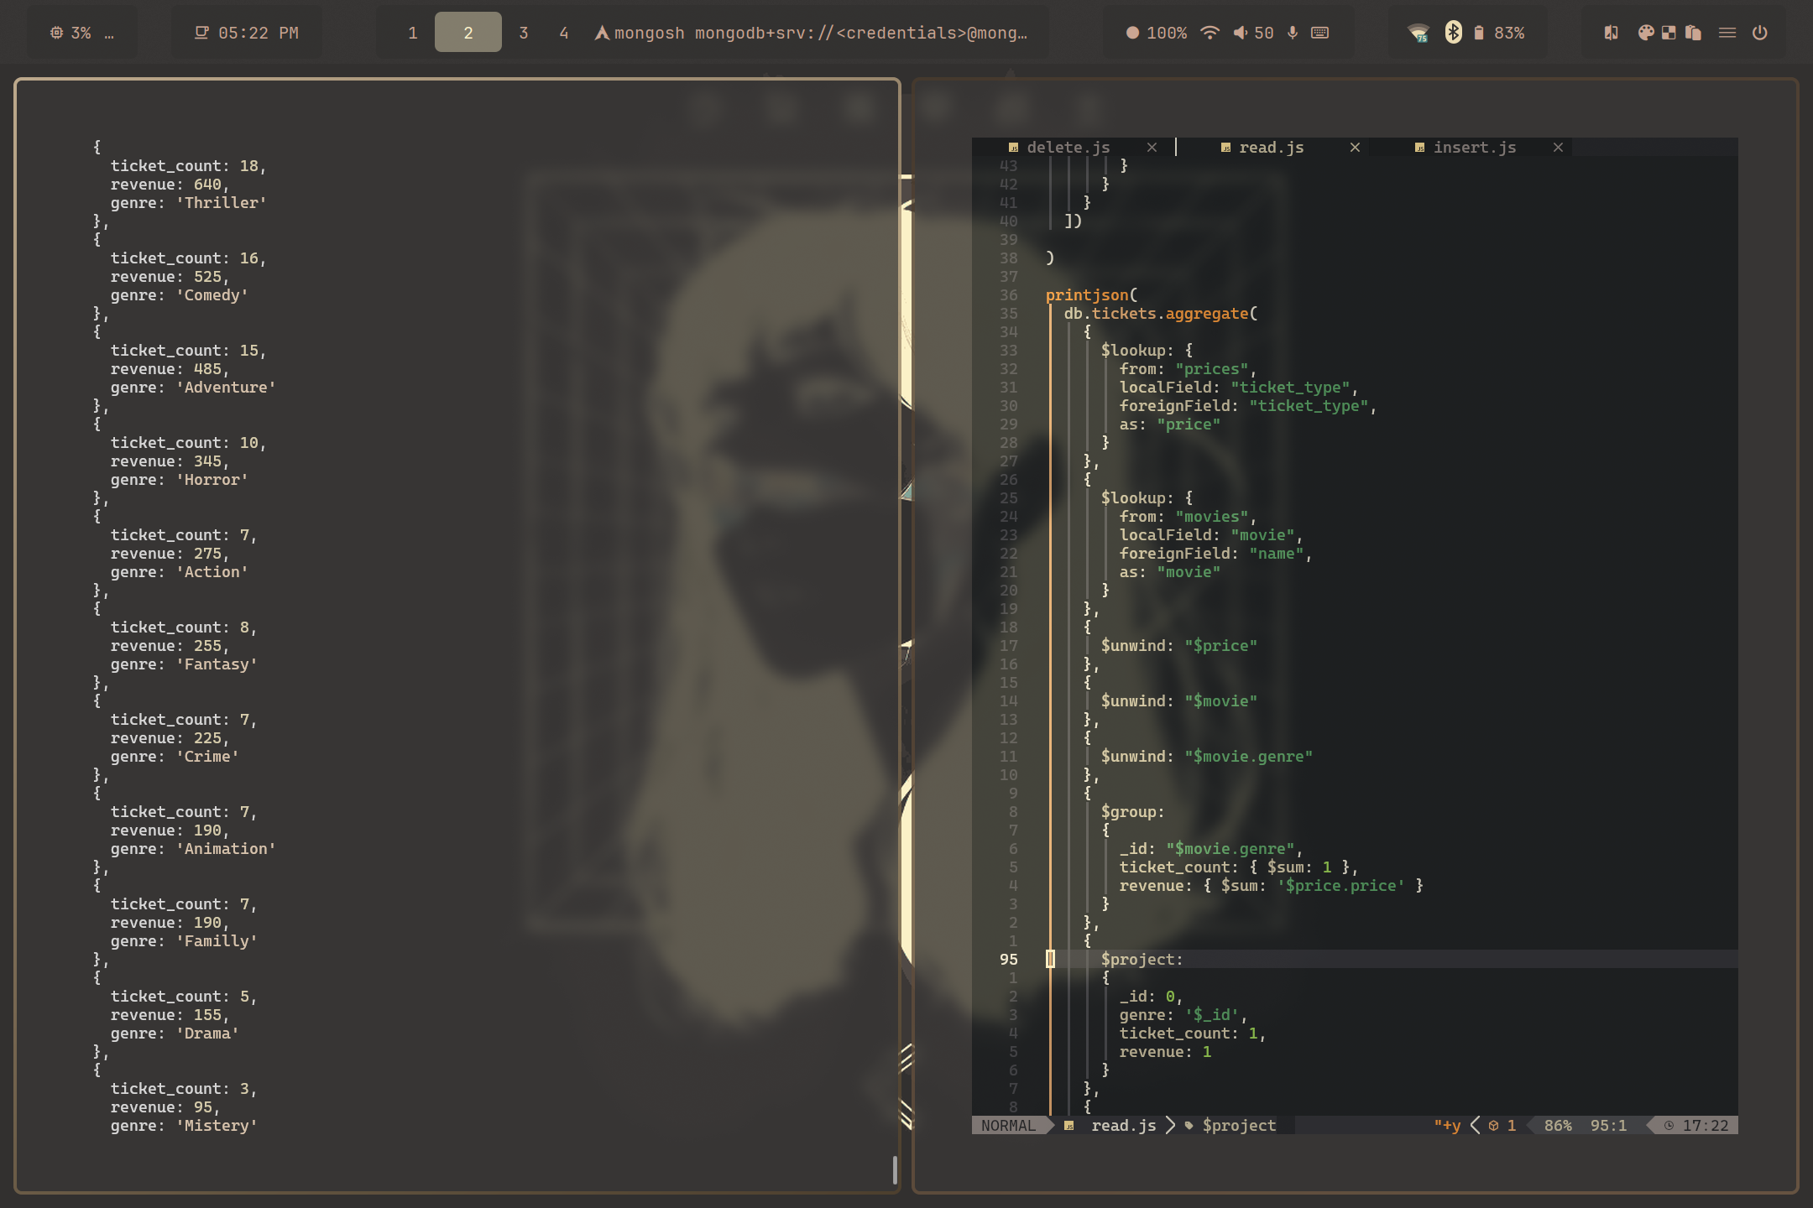

6. Clientul care a cumparat cele mai multe bilete  
  
printjson(

db.tickets.aggregate(

{

$lookup: {

from: "customers",

localField: "customer",

foreignField: "_id",

as: "customer"

}

},

{

$unwind: "$customer"

},

{

$group:

{

_id: '$customer',

ticket_count: { $sum: 1 }

}

},

{

$addFields:

{

fullname: { $concat: ['$_id.first_name', ' ', '$_id.last_name'] }

}

},

{

$project:

{

_id: 0,

fullname: 1,

ticket_count: 1

}

},

{

$sort: {

ticket_count: -1

}

},

{

$limit: 1

}

)

)

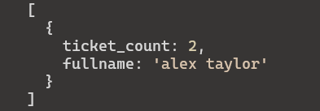

7. Stergere filme din anii anterior  
  
use('proiect');

let toDelete = db.movies.find({

date: {

$lt: new Date(new Date().getFullYear(), 0, 1)

}

})

.toArray()

.map(m => m.name);

db.movies.deleteMany({

name: { $in: toDelete }

});

db.tickets.deleteMany({

movie: { $in: toDelete }

})

printjson(

db.movies.find()

);

printjson(

db.tickets.find()

)

load('./proiect/create.js')

load('./proiect/insert.js');



8. Reduceri pentru categoria care a vandut cele mai multe bilete

use('proiect');

let category = db.tickets.aggregate(

{

$group: {

_id: "$ticket_type",

ticket_count: { $sum: 1 }

}

},

{

$sort: {

ticket_count: -1

}

},

{

$limit: 1

},

{

$project: {

_id: 0,

type: "$_id"

}

}

)

.toArray()

.map(c => c.type);

printjson(

db.prices.find(

{

ticket_type: { $in: category }

}

));

db.prices.updateMany(

{

ticket_type: { $in: category }

},

[

{

$set: {

price: { $multiply: ["$price", 0.75] }

}

}

]

);

printjson(

db.prices.find(

{

ticket_type: { $in: category }

}

));

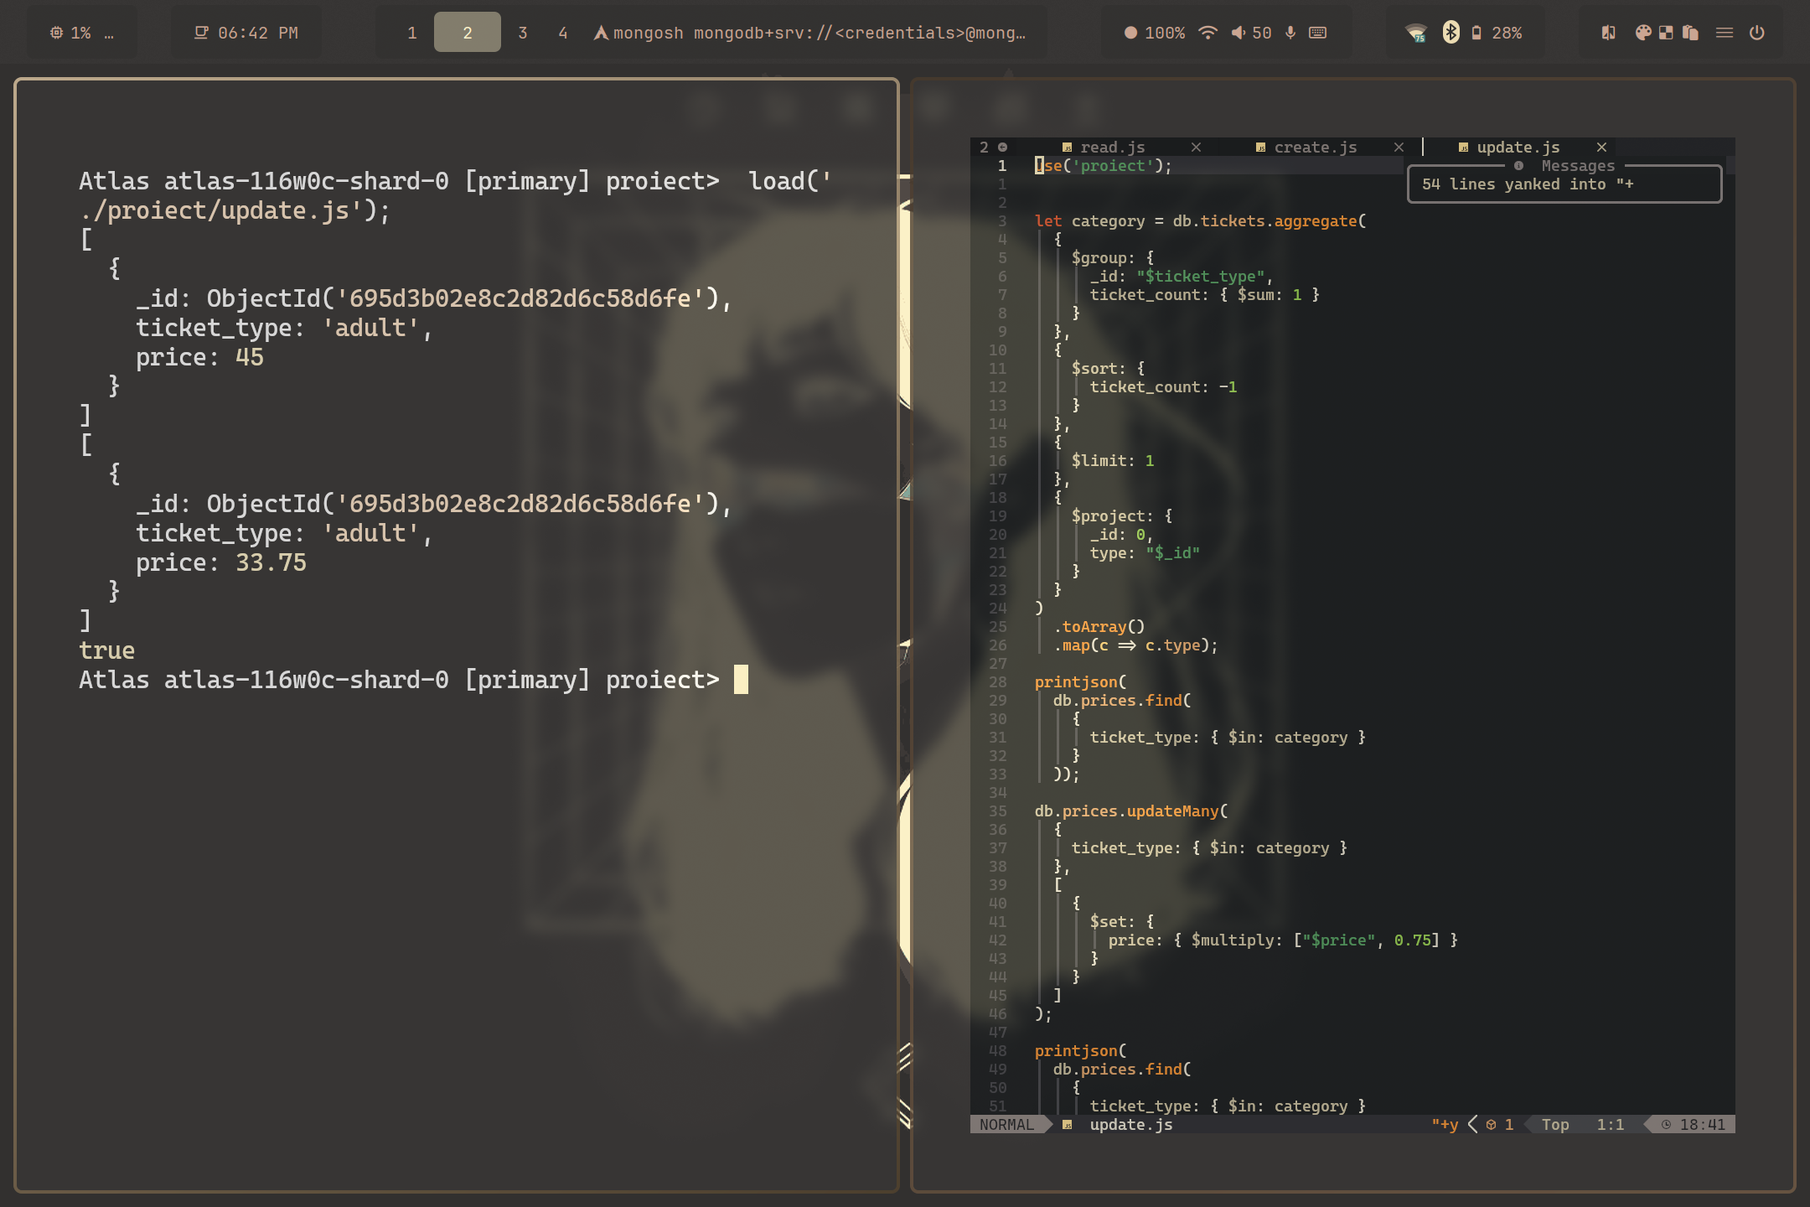  
9. Ora la care se termina filmul

printjson(

db.tickets.aggregate([

{

$lookup: {

from: "movies",

localField: "movie",

foreignField: "name",

as: "movie"

}

},

{ $unwind: "$movie" },

{

$addFields: {

end_time: {

$add: [

"$date",

{ $multiply: ["$movie.length_minutes", 60 * 1000] }

]

}

}

},

{

$project: {

_id: 0,

customer: 1,

movie: "$movie.name",

start_time: "$date",

end_time: 1

}

}

])

)



10. Stergere filme ce nu au vandut suficiente bilete

let bronzeMovies = db.tickets.aggregate([

{

$lookup: {

from: "prices",

localField: "ticket_type",

foreignField: "ticket_type",

as: "price"

}

},

{ $unwind: "$price" },

{

$group: {

_id: "$movie",

revenue: { $sum: "$price.price" }

}

},

{

$addFields: {

category: {

$switch: {

branches: [

{ case: { $lt: ["$revenue", 100] }, then: "bronze" },

{ case: { $lt: ["$totalRevenue", 200] }, then: "silver" },

],

default: "gold"

}

}

}

},

{ $match: { category: "bronze" } },

{

$project: {

_id: 0,

movie: "$_id",

totalRevenue: 1,

}

}

]).toArray().map(m => m.name);

db.movies.deleteMany({

name: { $in: bronzeMovies }

})

printjson(

db.movies.find()

);

load('./proiect/create.js')

load('./proiect/insert.js');

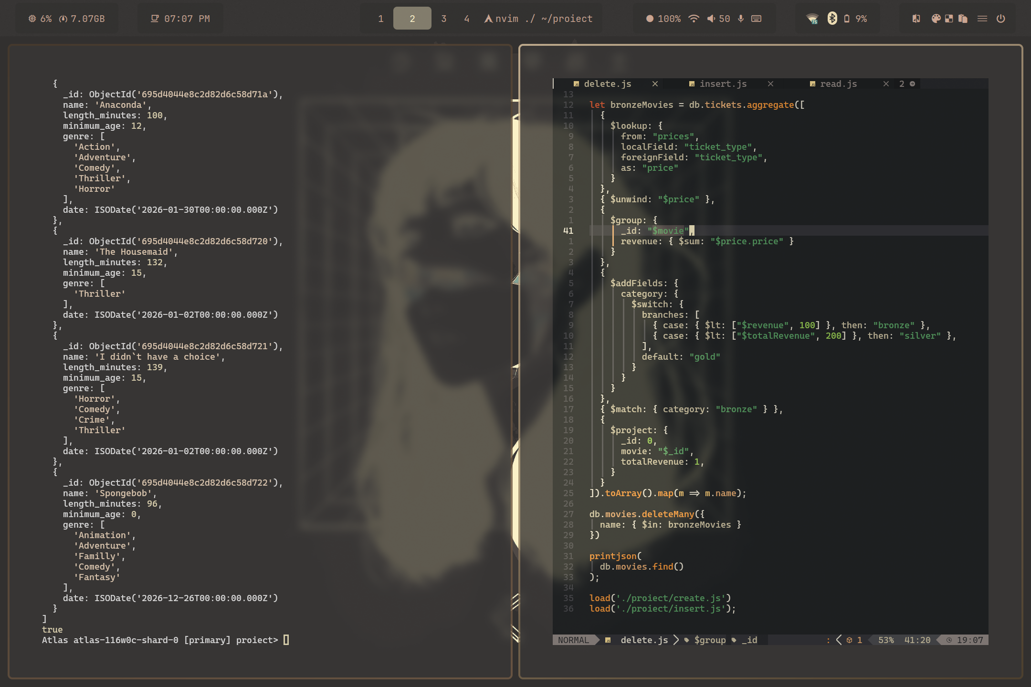  
  
Aplicatie  
  
Dashboard-uri si formulare pt adaugarea datelor:  
  
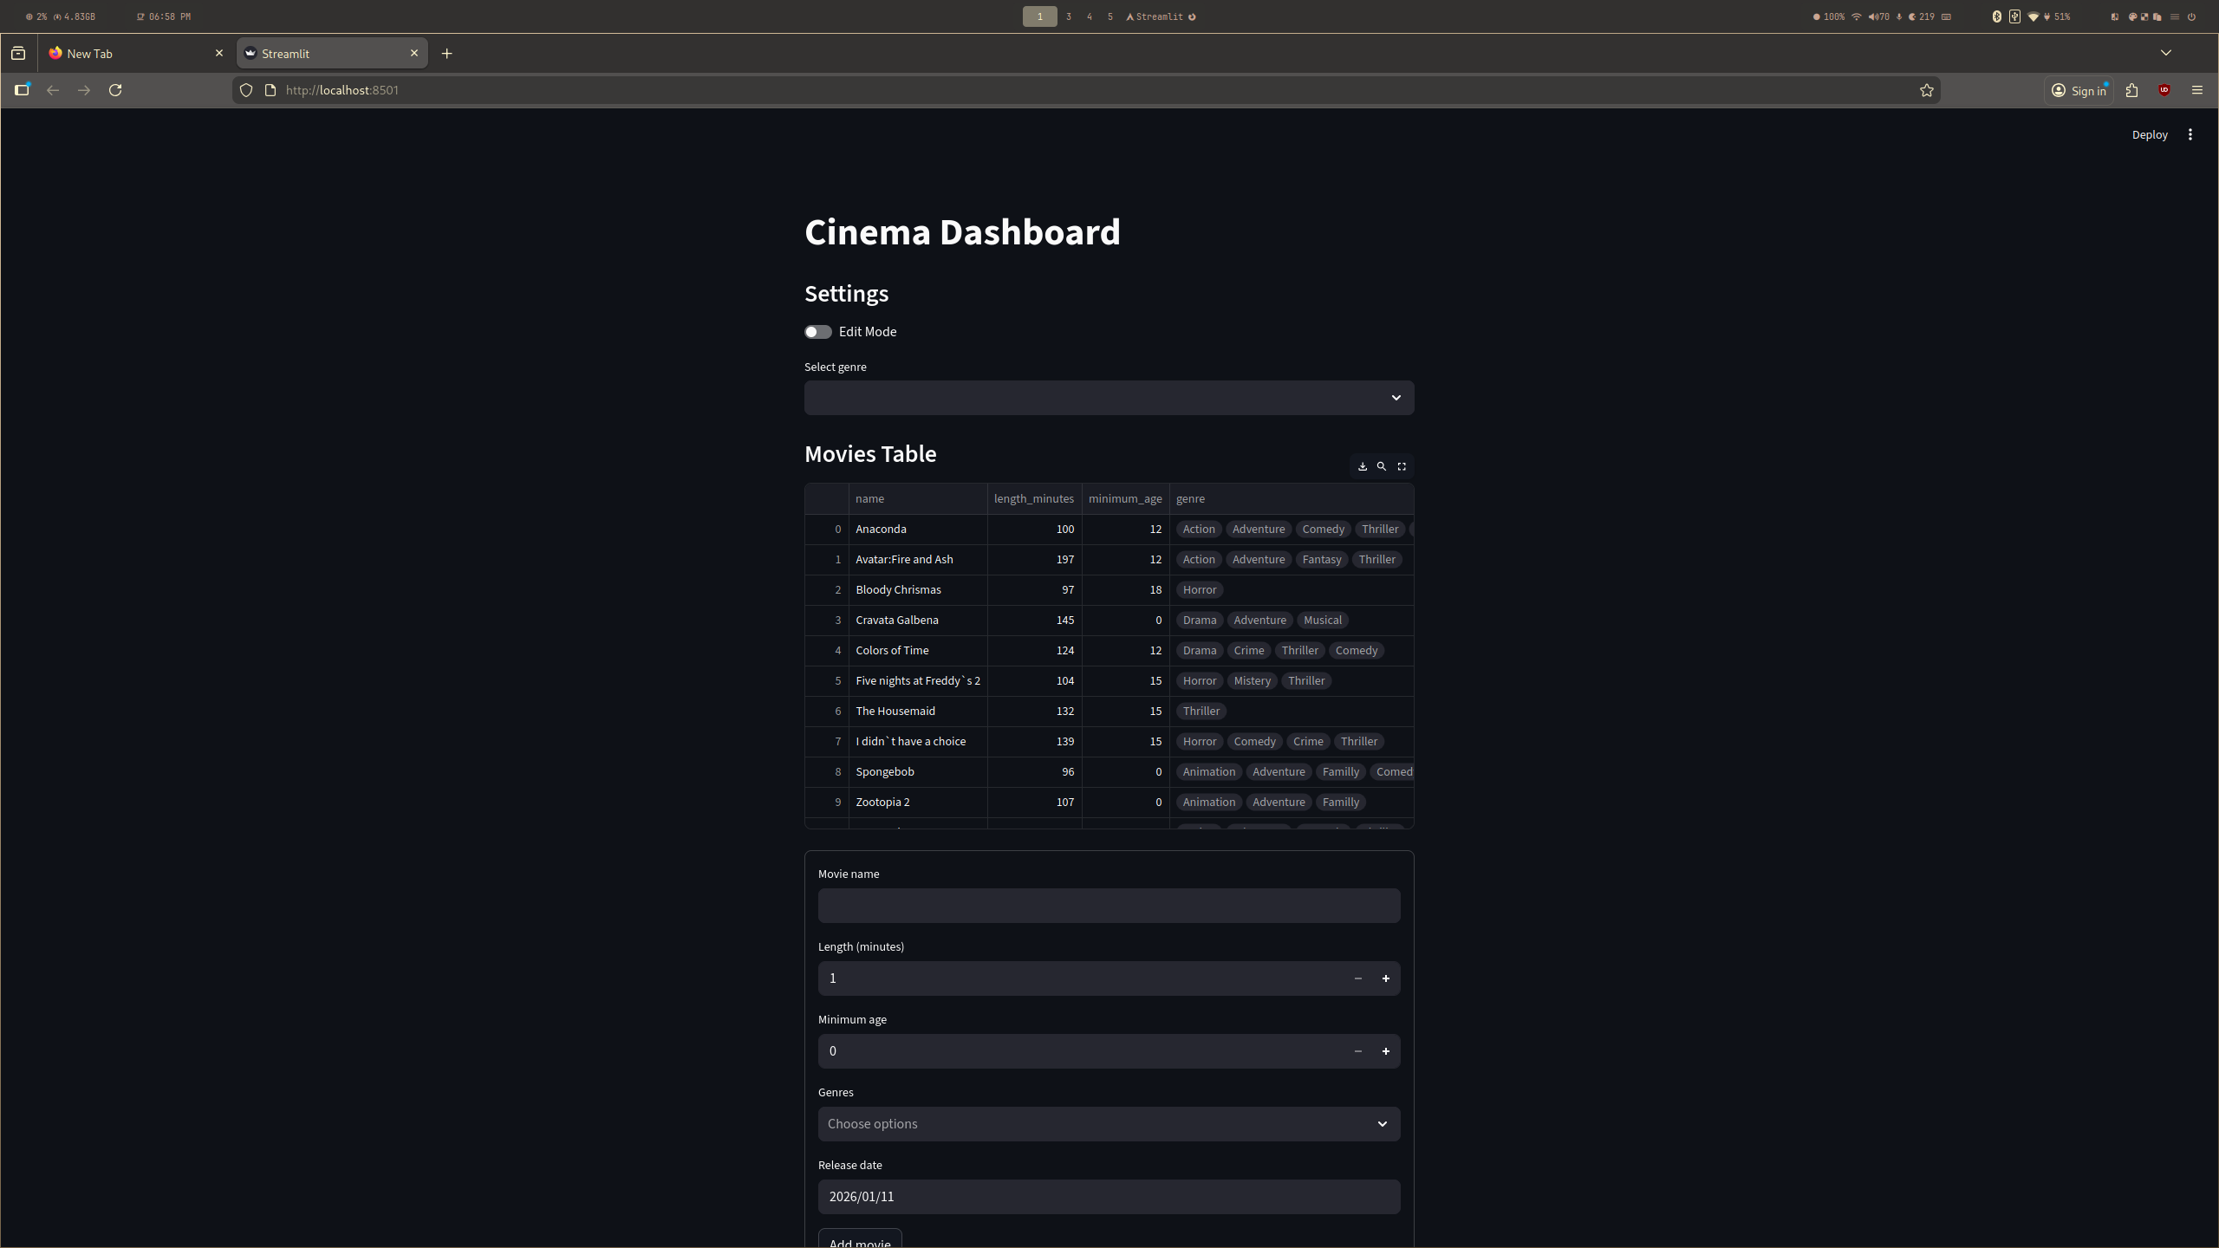

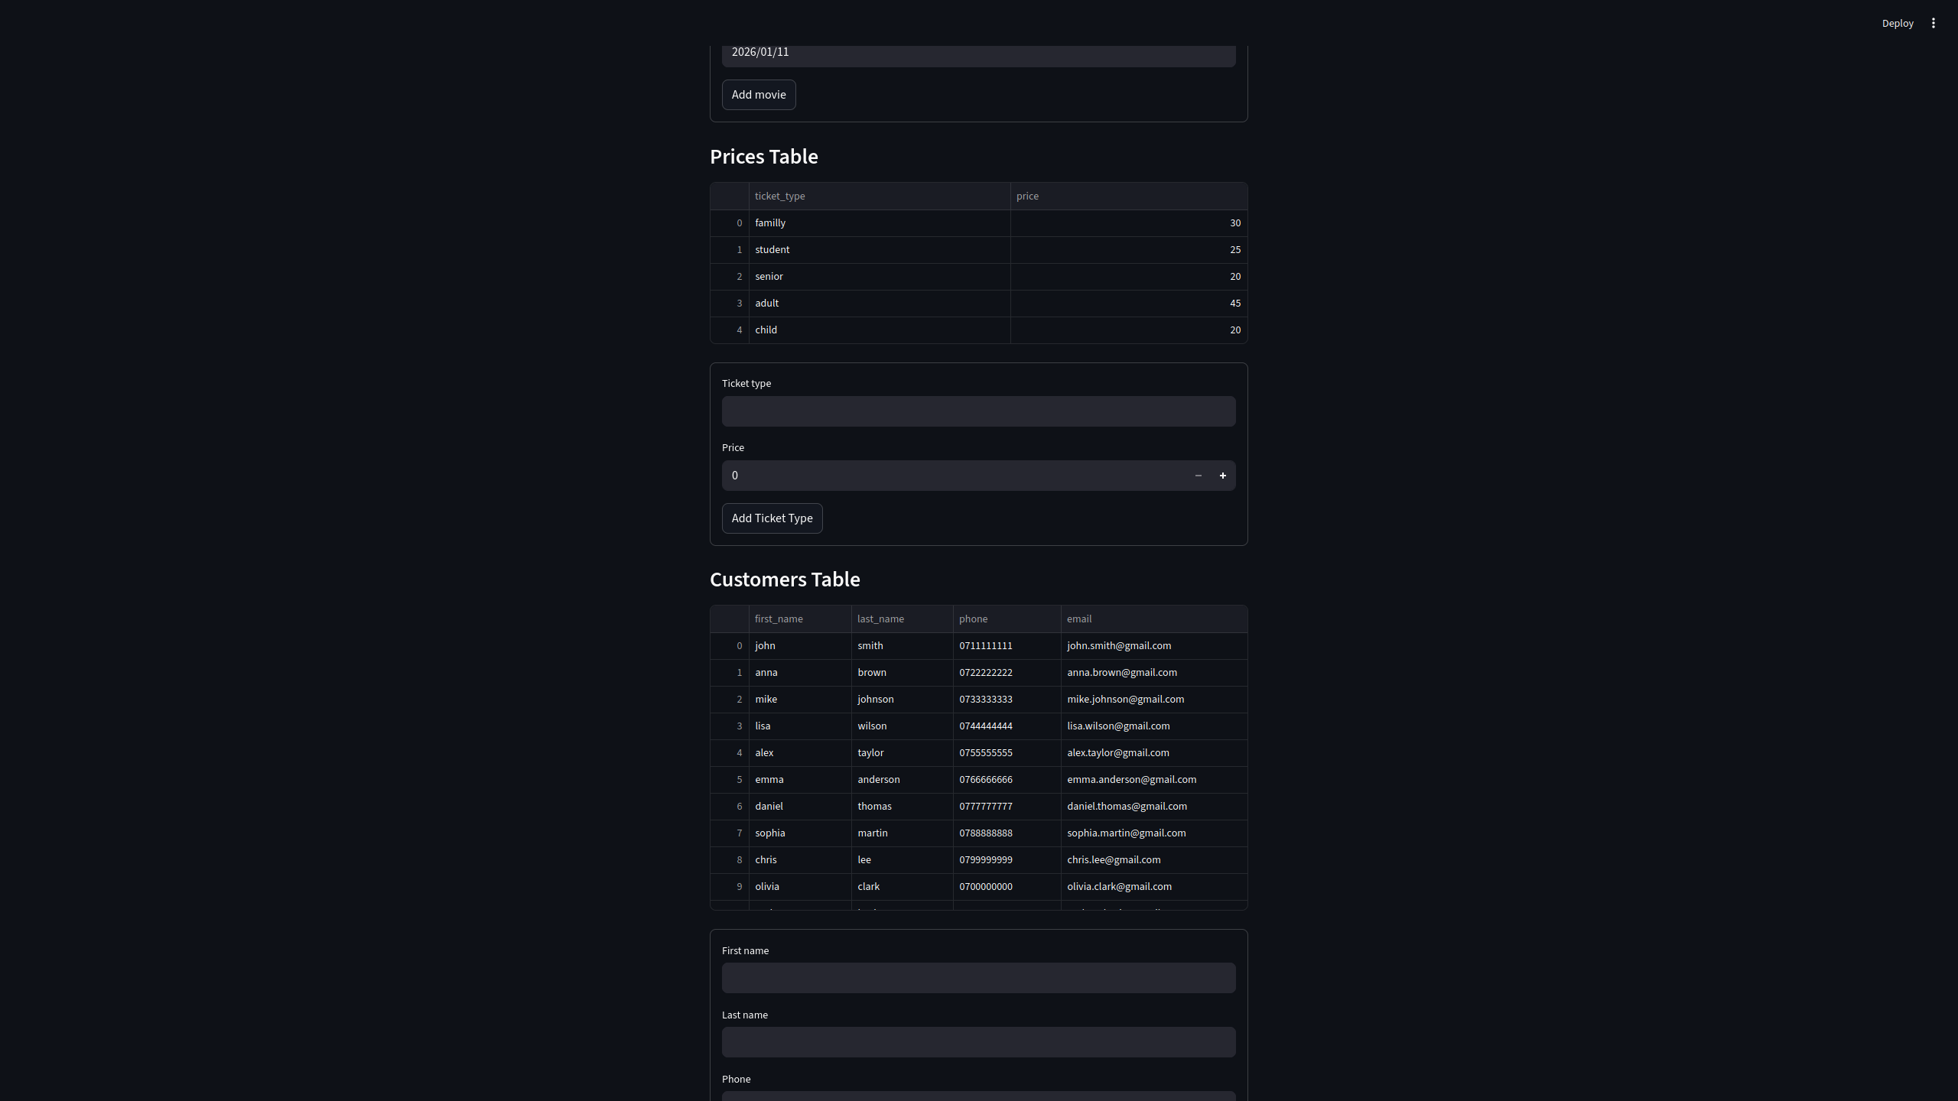

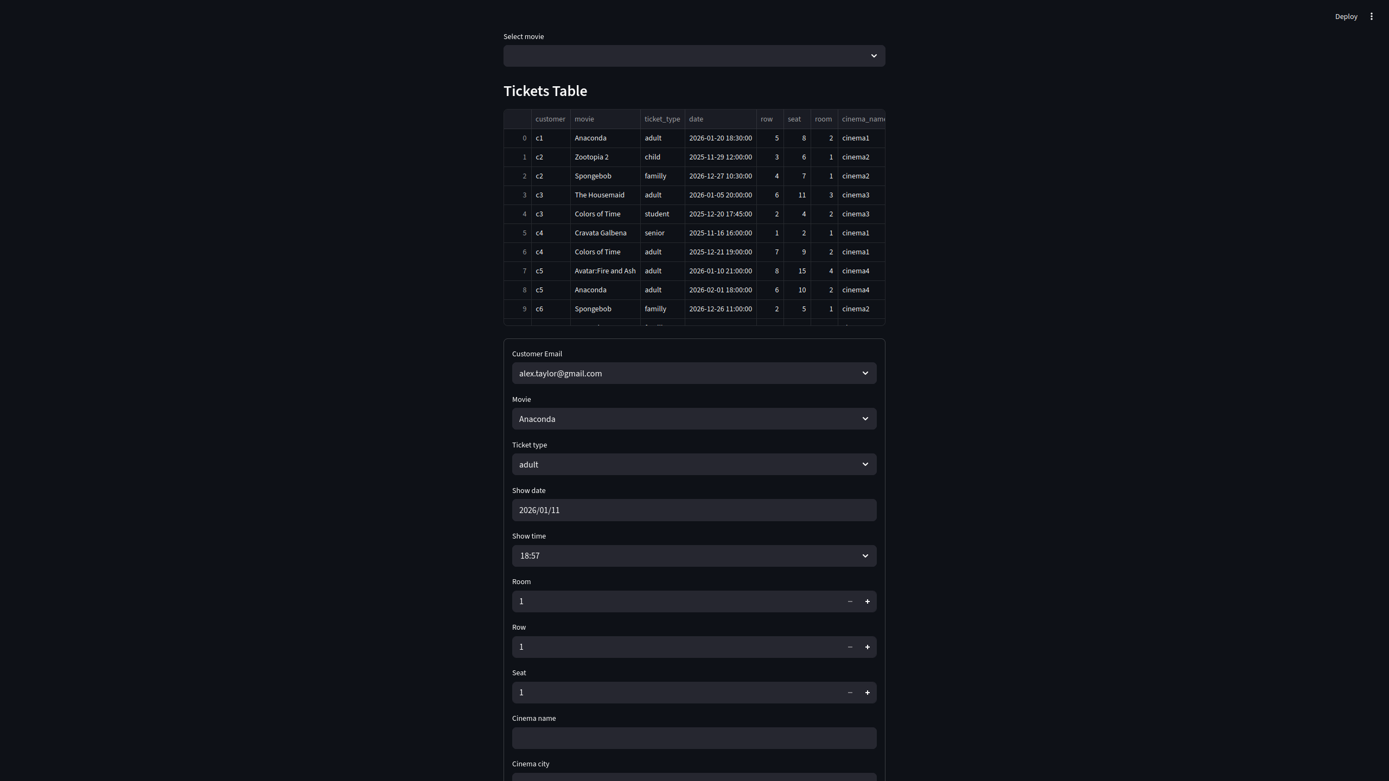

Grafic + Dashboard incasari per film

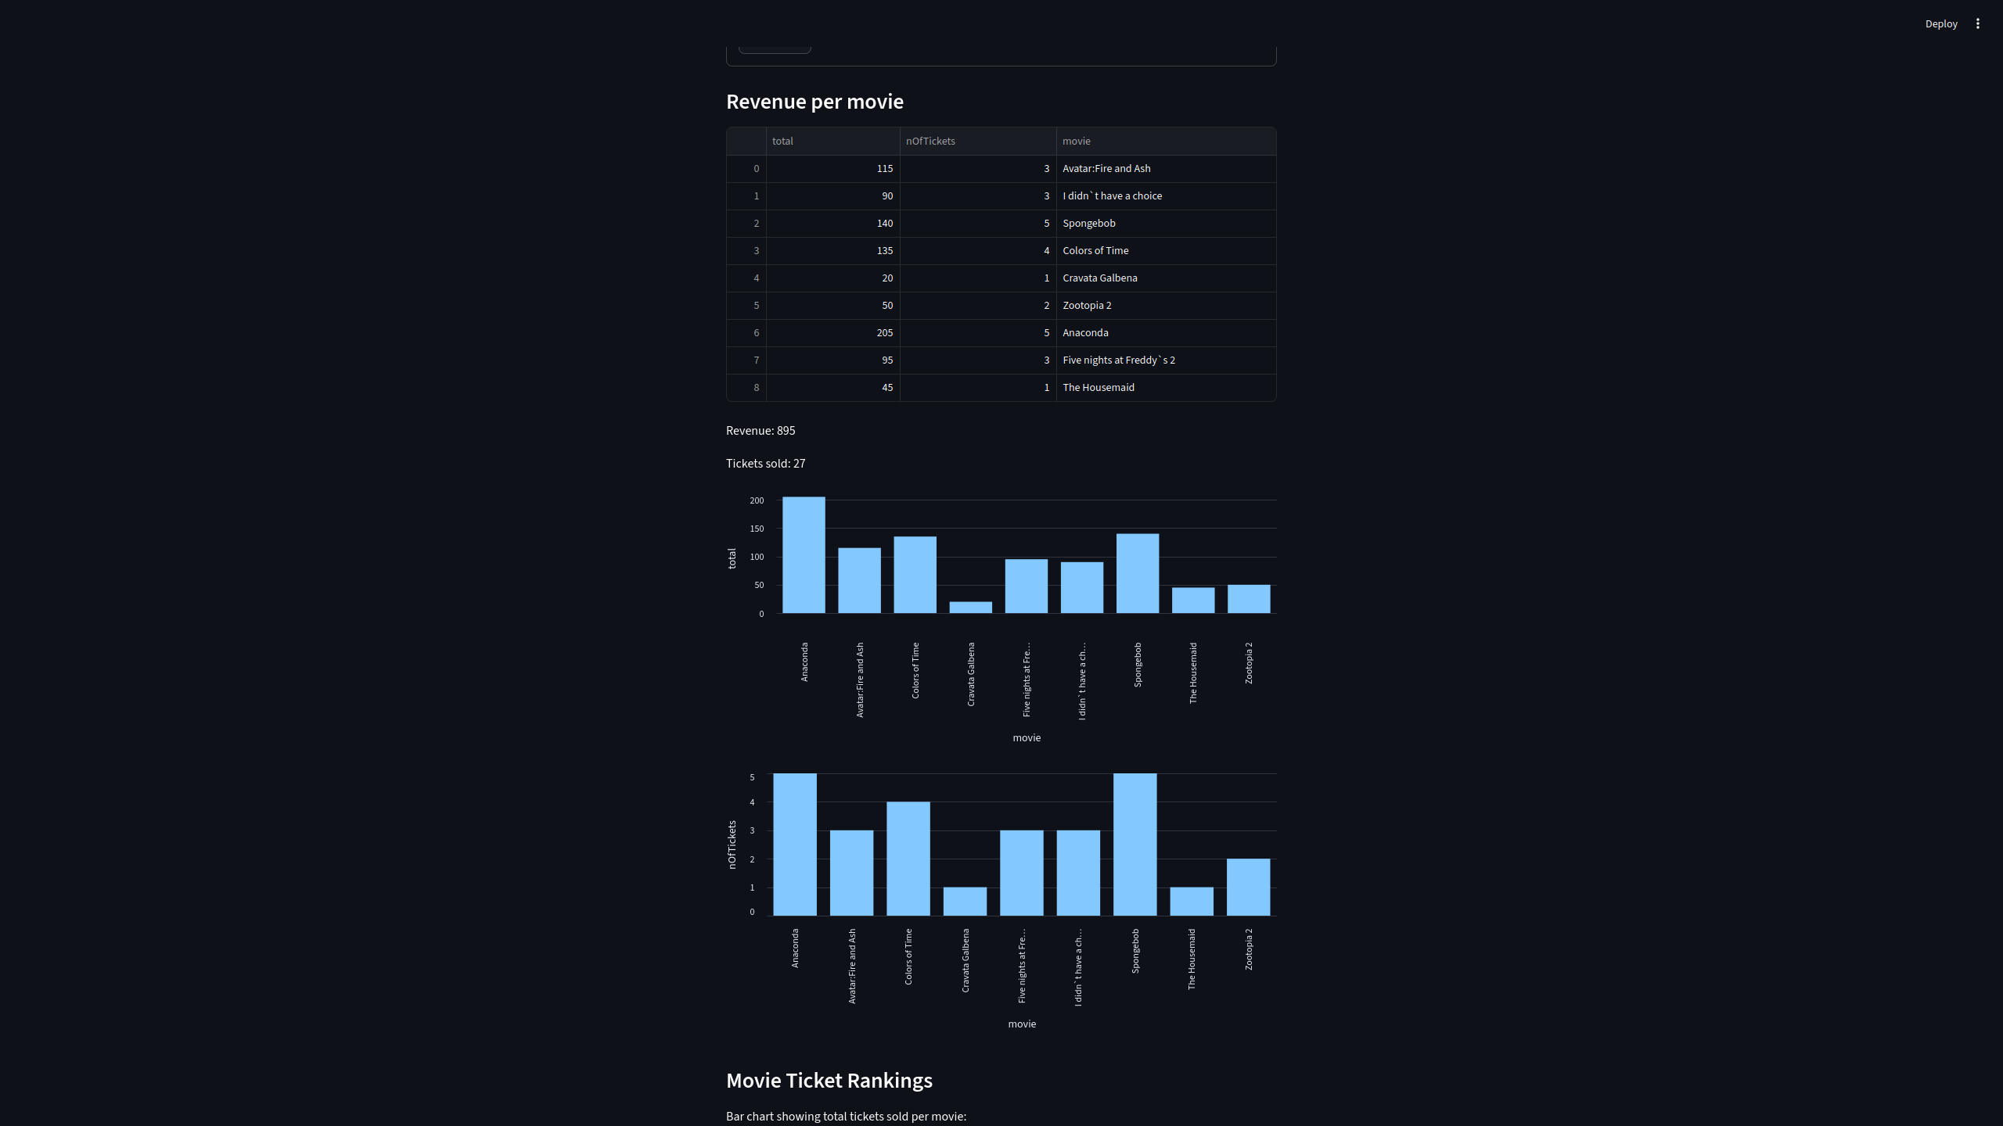

Grafic + Dashboard incasari categorie + top cele mai vizionate filme  
  
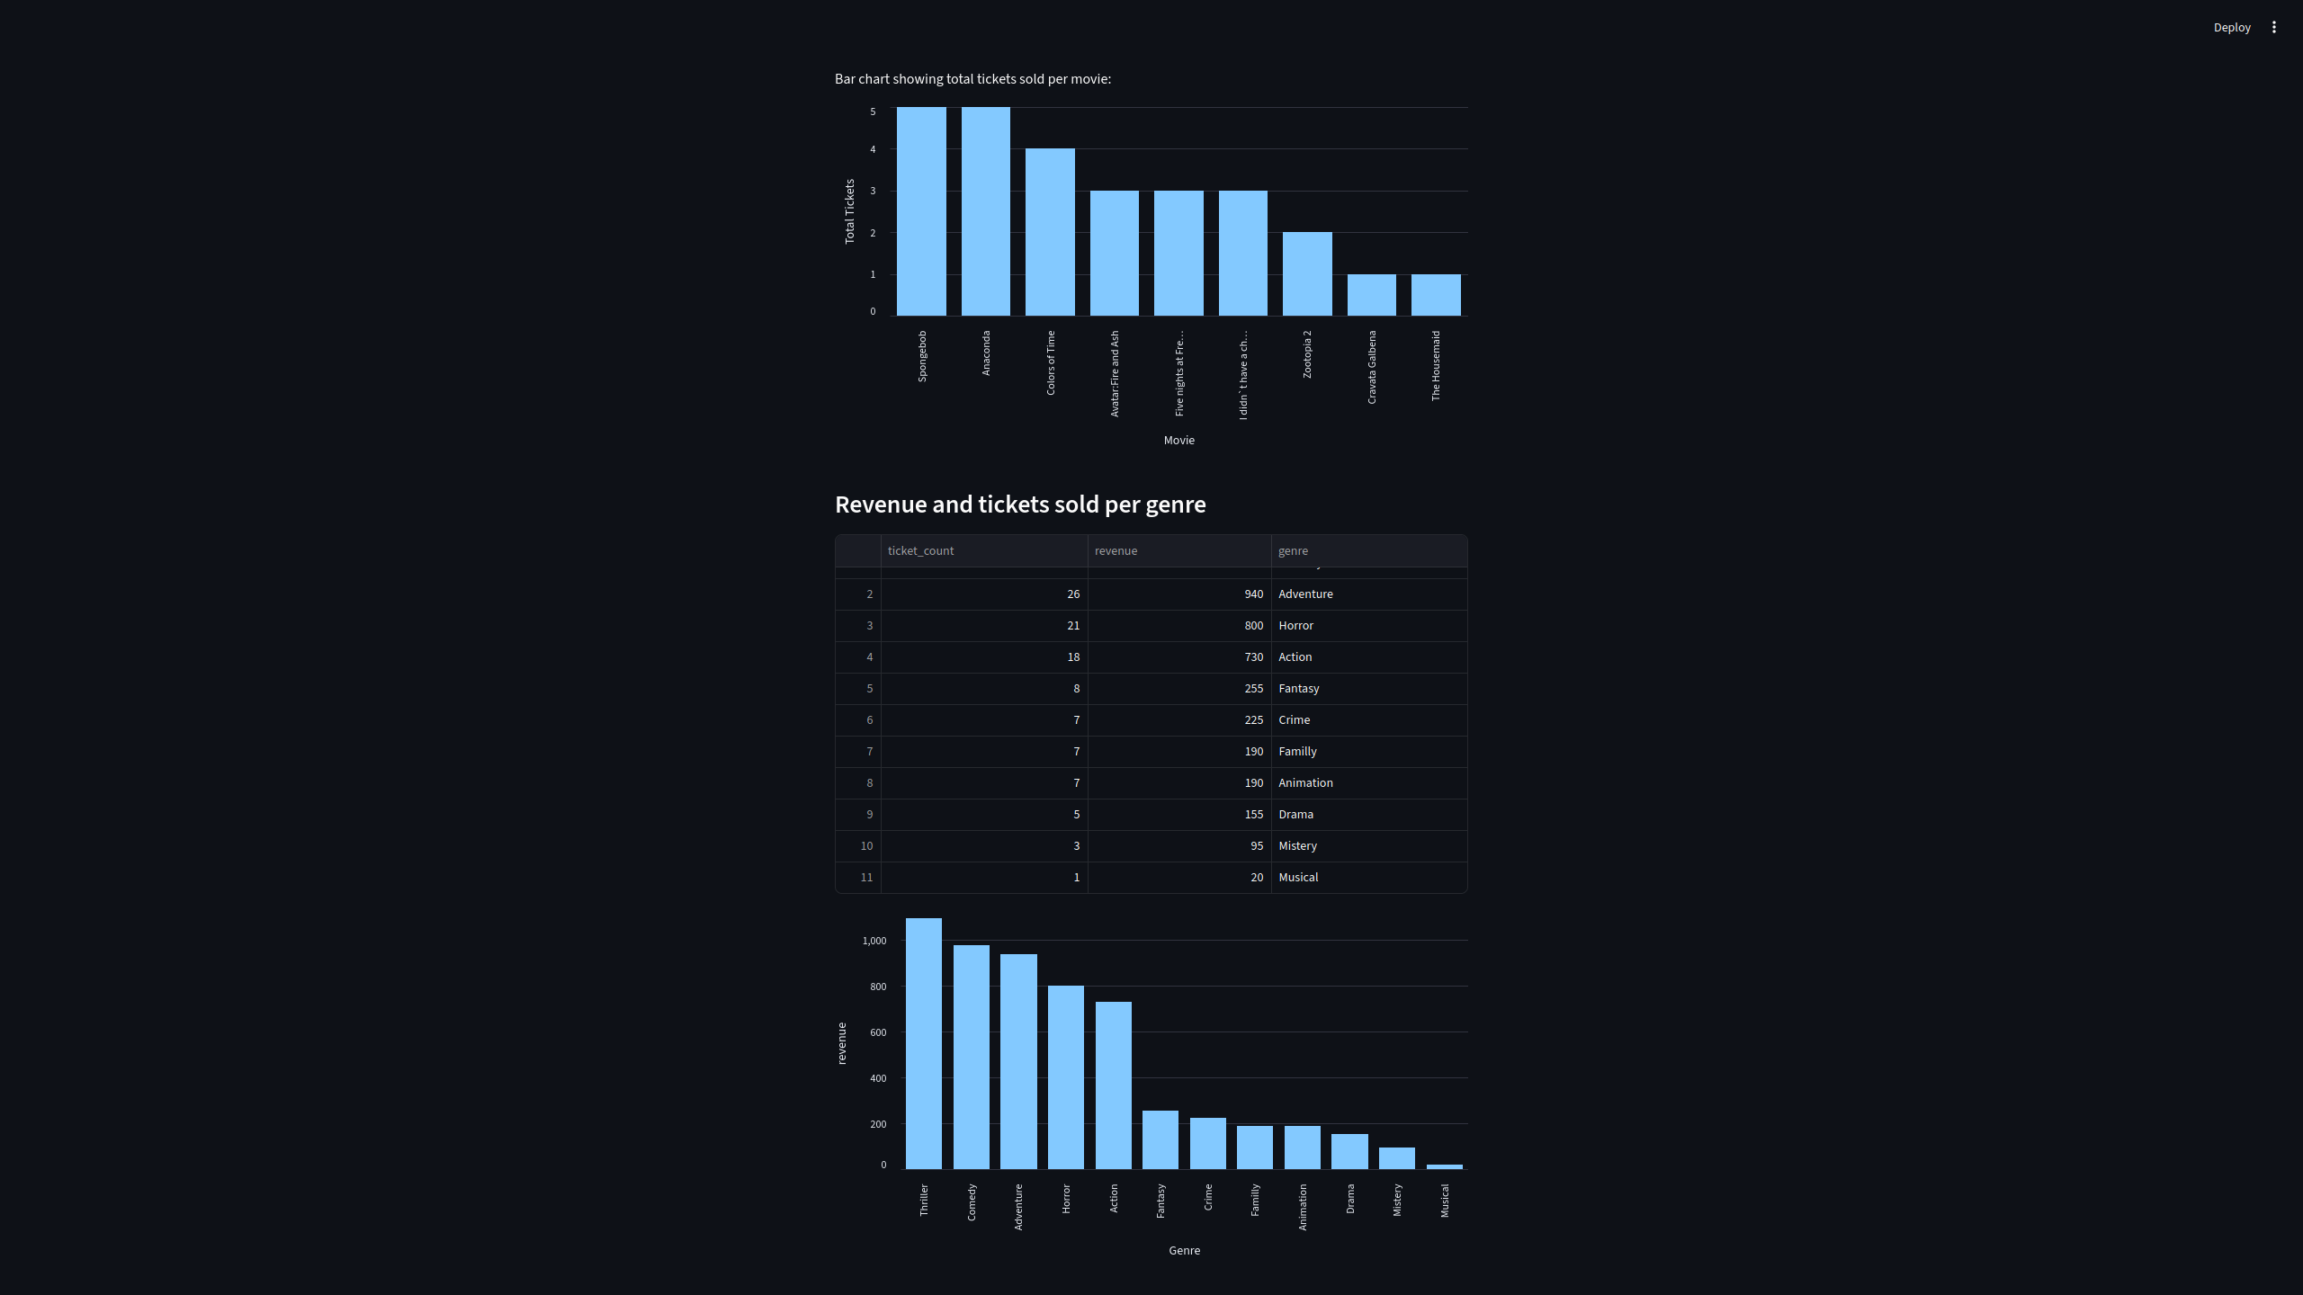  
  
  
  
  
  
  
  
  
  
  
  
  
  
  
  
  
  
  
  
  
  
Mod editare/stergere date

